**

## Step 2 : Create a VM instance:

Click on the three lines on the upper left corner, then on the compute option, click on ‘Compute Engine’

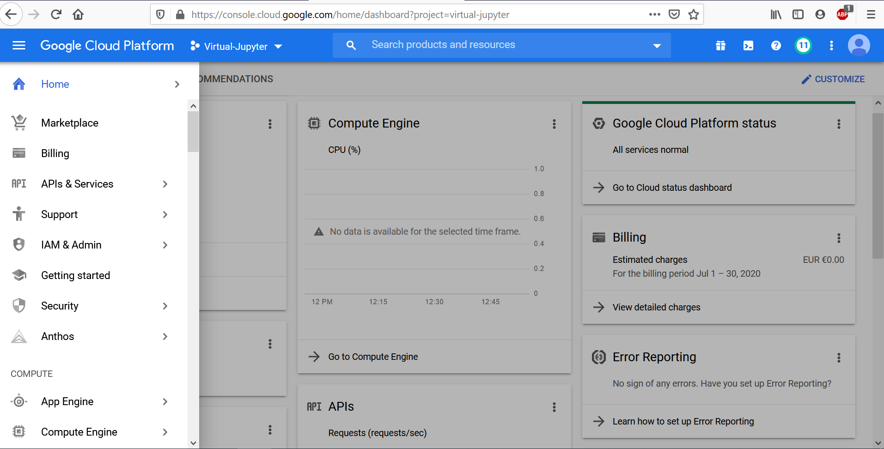

Now click on ‘Create new instance’. Name your instance, select zone as ‘ us-west1-b’. Choose your ‘machine type’. (I chose 8v CPUs).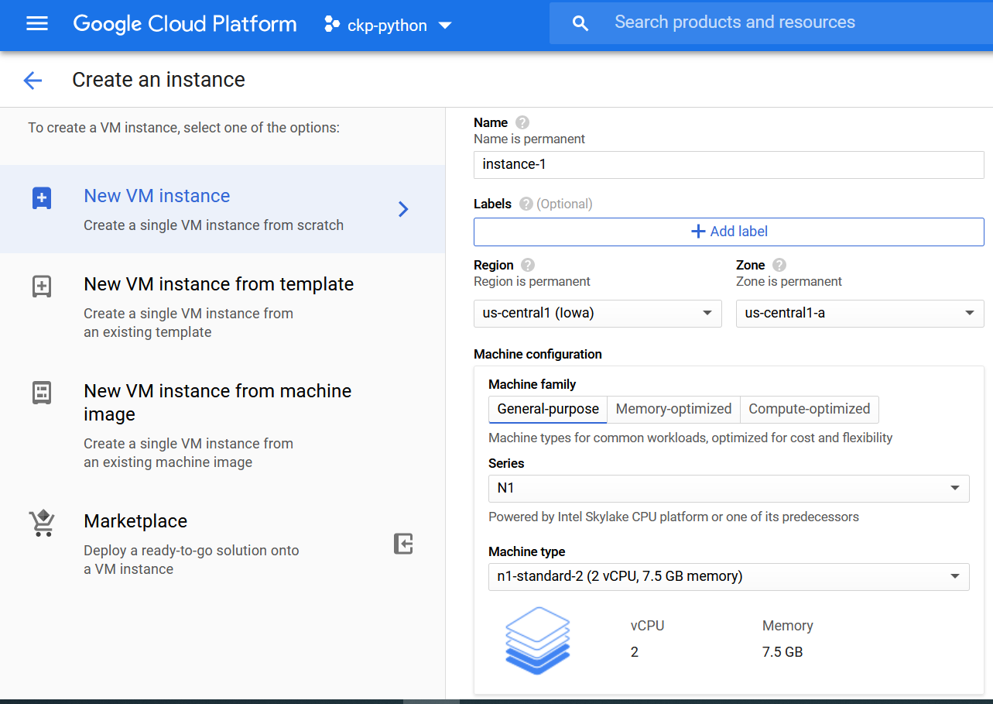

Select your boot disk as ‘Ubuntu 16.04 LTS’. Under the firewall options tick both ‘http’ and ‘https’ (very important).

Note: in the article it was Ubuntu but I chose Debian as my Boot disk

Your new VM instance should look something like this. Note down the External IP.

**Step 3: Make IP address static**

Click on the three horizontal lines on top left and then under networking, click on VPC network and then External IP addresses.

Change the type from Ephemeral to Static.

## Step 4: Change the Firewall setting

Now, click on the ‘Firewall’ setting below External IP address.

Fill the sections as below image. For tcp box you can choose any number you like. This number is your Port number.

## Step 5: Start your VM instance

Now start your VM instance. When you see the green tick click on SSH. This will open a command window and now you are inside the VM.

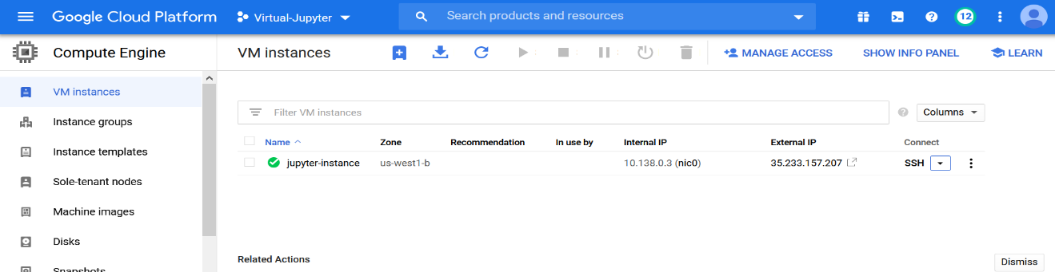

## Step 7: Install Jupyter notebook and other packages

In your SSH terminal, enter:

* wget <http://repo.continuum.io/archive/Anaconda3-4.0.0-Linux-x86_64.sh>
* bash Anaconda3-4.0.0-Linux-x86_64.sh

Note: I had to install wget first with $sudo apt-get install wget and then the last version of anaconda for Linux from following address: https://repo.anaconda.com/archive/Anaconda3-2020.07-Linux-x86_64.sh

* and follow the on-screen instructions. The defaults usually work fine, but answer yes to the last question about prepending the install location to PATH:

Do you wish the installer to prepend the   
Anaconda3 install location to PATH   
in your /home/haroldsoh/.bashrc ?   
[yes|no][no] >>> yes

I remember I had to install location to PATH manually because my disk was Debian not Ubuntu, but I do not remember what the trick was. I will update this part when I have a proper access to Cloud.

To make use of Anaconda right away, source your bashrc:

source ~/.bashrc

Now, install any package that you want:

conda install scikit-learn

## Step 8: Set up the VM server

Open up a SSH session to your VM. Check if you have a Jupyter configuration file:

ls ~/.jupyter/jupyter_notebook_config.py

If it doesn’t exist, create one:

jupyter notebook --generate-config

We’re going to add a few lines to your Jupyter configuration file with nano editor; open the jupyter configuration file with nano editor:

nano ~/.jupyter/jupyter_notebook_config.py

you should see a nano page in your termina, now add these lines:

c = get_config()  
c.NotebookApp.ip = '*'  
c.NotebookApp.open_browser = False  
c.NotebookApp.port = <Port Number>

it should look like this:

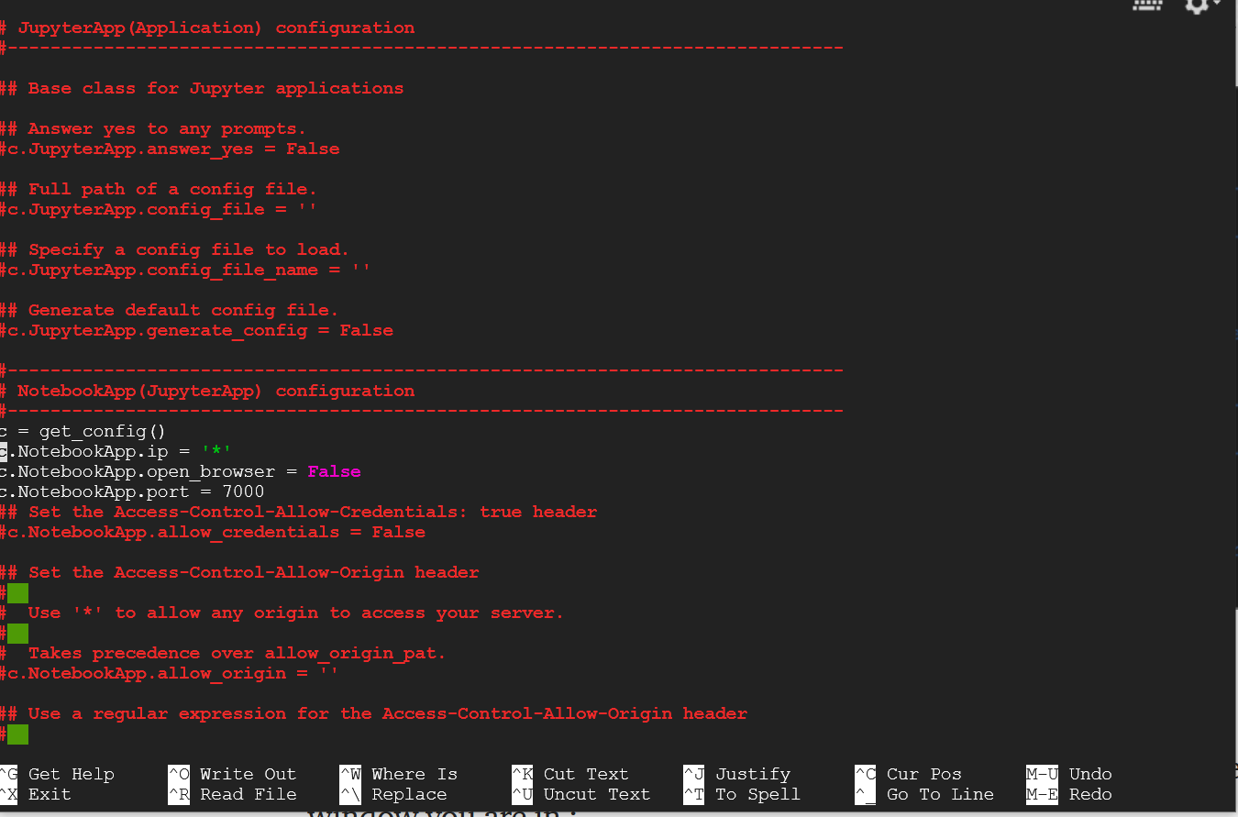

after adding the lines, press Ctrl+O to save and Ctrl+X to exit nano.

## Step 9: Launching Jupyter Notebook

To run the jupyter notebook, just type the following command in the ssh window you are in:

jupyter-notebook --no-browser --port=<PORT-NUMBER>

Now to launch your jupyter notebook, just type the following in your browser:

http://<External Static IP Address>:<Port Number>

where, external ip address is the ip address which we made static and port number is the one which we allowed firewall access to.

## ATTENTION — DO NOT FORGET TO STOP THE VM INSTANCE!! You can find the option in three dots next to SSH button

Reference: https://towardsdatascience.com/running-jupyter-notebook-in-google-cloud-platform-in-15-min-61e16da34d52